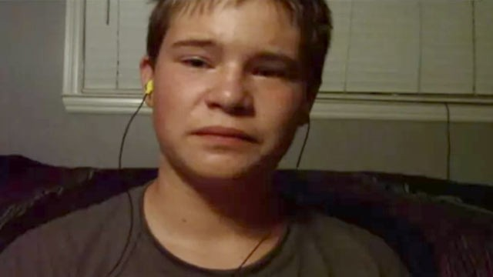

### OPHS Pavilion

### March 5 @ 7pm

### Presented by OPHS Adv. Peer Counseling

## Join us in the Pavilion to share resources and discuss in an interactive forum with experts the issues surrounding teen depression and suicide. Topics include signs and symptoms, interventions, and teen stress. Help us to remove the stigma of mental illness and to support our kids.

Monday, March 5 in the Pavilion @ 7pm

Oak Park High School

Teen Depression

Awareness Forum

# What’s going on behind the mask with teens?

* Expert Panel Discussion
* Adv. Peer Counselors
* The Luddington Institute
* OPHS Counselors
* Organic Pest Management

### Teen Crisis Forum